Digital library

A Project Report Submitted
for

Information Technology
By

Praveen Kumar Joshi
(Roll no. 170180705006)

Under the guidance of
Mr. Praveen Kumar Joshi

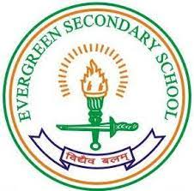

EVER GREEN SENIOR SECONDARY SCHOOL
(GOVERNED BY EDUCATIONAL WELFARE SOCIETY)
TULARAMPUR -2263139 , DISTRICT-NAINITAL
UTTARAKHAND, INDIA

OCTOBER, 2021

CERTIFICATE

This is to certify that the project entitled “Digital library” being submitted to Evergeen Senior Secondary School, haldwani for the project work of INFORMATION TECHNOLOGY is a record of the work carried by MR. PRAVEEN KUMAR JOSHI under my guidance and supervision.

Date: 5/10/2021 Supervisor
MR. PRAVEENJOSHI
TGT Computer
Ever Green Sr. Sec. School, Haldwani
Forwarded By:
MR. M.S. PARWAL
Principal
Ever Green Sr. Sec. School, Haldwani

ABSTRACT
In this project I learn that what is digital library what are the advantages of digital library, what are the disadvantage of digital library , use of digital library in our daily life .In digital library we can get easily everything . There are lots of contents in digital library . And it’s have amazing features . I just want to thank my teacher Mr Praveen Joshi that he give me this project . It was very interesting and It is a opportunity that my teacher give me to tell my classmates what I’m . I learn many things about digital library and I hope you also learn something.

ACKNOWLEDGEMENTS
I would like to express my most sincere heartfelt gratitude and respect to my supervisor MR. PRAVEEN JOSHI, for suggesting the topic for my project work and for his excellent guidance, valuable suggestions and endless support throughout for preparing the report. I am greatly indebted to him for his constructive suggestions and criticism from time to time during the course of progress of my work.
I would like to express my gratitude and sincere thanks to Mr. M.S. Parwal, Principal of School, and entire faculty who has imparted considerable knowledge to me.
Finally, I express my deepest gratitude to my parents for their continuous encouragement, understanding and support.

Nik)

TABLE OF CONTENTS

Chapter | Title | Page no
 | Certificate
 | Acknowledgment
 | List of figure
 | Abstract
 | Introduction
1 | Advantages of digital library | 4-5
2 | Disadvantages of digital library | 5-6
3 | Type of digital library | 6-7
4 | Features of digital library | 7-8
5 | Future development | 8-9
 | Reference | 8-9

LIST OF FIGURES

S.No. | Name | Page No.
1. | Digital library | 6
2. | National digital library | 7
3. | Traditional Library | 7
4.
5.
6.
7.
Introduction of digital library

Digital library is good for us because by the help of digital library we can save our tree . In the digital library there is no waste of time , money , no waste of paper it’s save our money also . Digital library is also known as online library In digital library there is lots of contents , more information . It’s help our to improve your communication skills because by reading book we can know the word that we should have to used . Digital library is published by Michael stern hart born in 8 March 1943 in Tacoma the first digital library named as project Gutenberg . In digital library there are various types of book , video text , information are included.
Advantages of digital library
- In digital library it saves time
- We can get information 24 hours in digital library
- It is paperless
- It saves money

Disadvantages of digital library
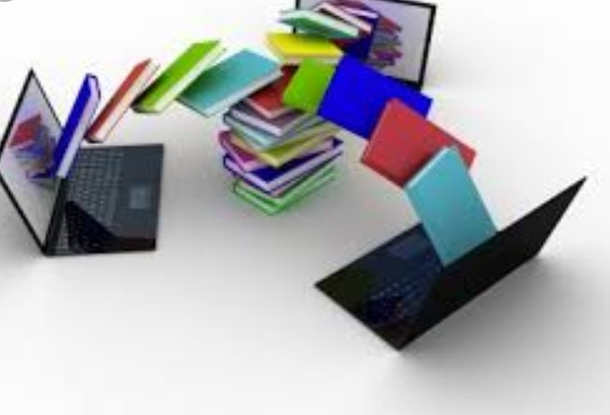
- High initial cost
- A digital library can’t reproduce the environment of a traditional Library .
- Digital library needs high bandwidth network for transfer of multimedia resources.

Type of digital library

National library :Legal deposit is often covered by copyright legislation and sometimes by laws specific to legal deposit, and requires that one or more copies of all material published in a country should be submitted for preservation in an institution, typically the national library.
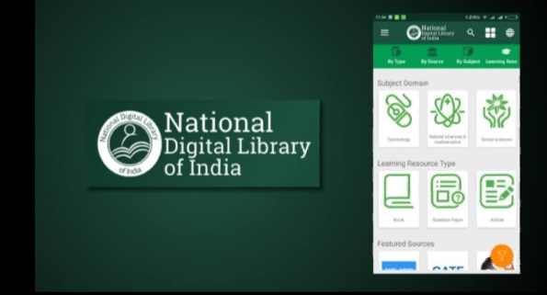
Traditional Library : Traditional library are limited by storage digital library have the potential to store much more information simply because digital information required very little physical space to contain it . As such the cost be much lower than that of a traditional Library .
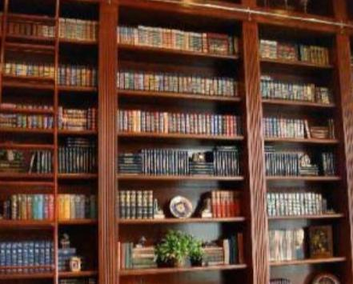
Digital object: The actual content of digital libraries is made up of a number of digital object In some case these may be thought of as data set such as a table of results the genomic information for an individual

Metadata : Digital object are described structure summarised managed and otherwise manipulate in surrogate form through the use of metadata about data . Three types are often distinguished , descriptive structural and administrative .
- Digital archive : Early project centered on the creation of an electronic card catalogue known as online public access catalog (OPAC) by the 1980s the success of these endeavors resulted in OPAC replacing the traditional card catalogue in many academic public and special libraries . This permanent library to undertake additional rewarding co-operative efforts to support resources sharing and expend access to Library material and beyond an individual library . Archival descriptions are the fundamental means to describe, understand, retrieve and access archival material. At the digital level, archival descriptions are usually encoded by means of the Encoded Archival Description XML format. The EAD is a standardized electronic representation of archival description which makes it possible to provide union access to detailed archival descriptions and resources in repositories distributed throughout the world.
Features of digital library
Digital archives are an evolving medium and they develop under various circumstances. Alongside large scale repositories, other digital archiving projects have also evolved in response to needs in research and research communication on various institutional levels. For example, during the COVID-19 pandemic, libraries and higher education institutions have launched digital archiving projects to document life during the pandemic, thus creating a digital, cultural record of collective memories from the period. Researchers have also utilized digital archiving to create specialized research databases. These databases compile digital records for use on international and interdisciplinary levels. COVID CORPUS, launched in October 2020, is an example of such a database, built in response to scientific communication needs in light of the pandemic.Beyond academia, digital collections have also recently been developed to appeal to a more general audience, as is the case with the Selected General Audience Content of the Internet-First University Press developed by Cornell University. This general-audience database contains specialized research information but is digitally organized for accessibility.
- No physical boundary: The user of a digital library need not to go to the library physically; people from all over the world can gain access to the same information, as long as an Internet connection is available.
Software- There are a number of software packages for use in general digital libraries (for notable ones see Category:Digital library software). Institutional repository software, which focuses primarily on ingest, preservation and access of locally produced documents, particularly locally produced academic outputs, can be found in Institutional repository software. This software may be proprietary, as is the case with the Library of Congress which uses Digiboard and CTS to manage digital content.

—and of Edit Searching
Most digital libraries provide a search interface which allows resources to be found. These resources are typically deep web (or invisible web) resources since they frequently cannot be located by search engine crawlers. Some digital libraries create special pages or sitemaps to allow search engines to find all their resources. Digital libraries frequently use the Open Archives Initiative Protocol for Metadata Harvesting (OAI-PMH) to expose their metadata to other digital libraries, and search engines like Google Scholar, Yahoo! and Scirus can also use OAI-PMH to find these deep web resources.

Future development

Digital Large scale digitization projects are underway at Google, the Million Book Project, and Internet Archive. With continued improvements in book handling and presentation technologies such as optical character recognition and development of alternative depositories and business models, digital libraries are rapidly growing in popularity. Just as libraries have ventured into audio and video collections, so have digital libraries such as the Internet Archive. Google Books project recently received a court victory on proceeding with their book-scanning project that was halted by the Authors' guild. This helped open the road for libraries to work with Google to better reach patrons who are accustomed to computerized information.
According to Larry Lannom, Director of Information Management Technology at the nonprofit Corporation for National Research Initiatives (CNRI), "all the problems associated with digital libraries are wrapped up in archiving." He goes on to state, "If in 100 years people can still read your article, we'll have solved the problem." Daniel Akst, author of The Webster Chronicle, proposes that "the future of libraries—and of information—is digital." Peter Lyman and Hal Variant, information scientists at the University of California, Berkeley, estimate that "the world's total yearly production of print, film, optical, and magnetic content would require roughly 1.5 billion gigabytes of storage." Therefore, they believe that "soon it will be technologically possible for an average person to access virtually all recorded information.”
A
References

- ). How to Build a Digital Library (2nd ed.). Morgan Kaufman. ISBN 9780080890395.
- ^ Lanagan, James; Smeaton, Alan F. (September 2012). "Video digital libraries: contributive and decentralized". International Journal on Digital Libraries. 12 (4): 159–178. doi:10.1007/s00799-012-0078-z. S2CID 14811914.
- ^ Lynch, Clifford (2005). "Where Do We Go From Here? The Next Decade for Digital Libraries". D-Lib Magazine. 11 (7/8). doi:10.1045/july2005-lynch. ISSN 1082-9873. This is a field with an incredibly rich, and, as yet, poorly chronicled pre-history and early history. There is a stream of work and ideas that reaches back to at least the turn of the 20th century, and includes such thinkers as H.G. Wells and Paul Otlet; later contributors to the pre-history of visions of new, technologically-enabled means of knowledge organization, access and distribution also include Vannevar Bush and J.C.R. Licklider.
- ^ Stocker, Gerfried (1 January 2014). "Beyond Archives (or the Internet 100 years before the Internet)". In Magalhães, Ana Gonçalves; Beiguelman, Giselle (eds.). Possible Futures: Art, Museums and Digital Archives. ISBN 9788575963548. Retrieved 30 April2018. Actually it was 1895 when Paul Otlet together with Henry La Fontaine, who was later awarded the Nobel Peace Prize, started a project – Mundaneum – that was initiated and driven by their idea that, if they would be able to collect all human knowledge and make it accessible to everybody worldwide, then this would bring about peace on Earth.
- ^ Schatz, Bruce (1997). "Information Retrieval in Digital Libraries: Bringing Search to the Net". Science. 275 (5298): 327–334. doi:10.1126/science.275.5298.327. PMID 8994022.

- Bush, Vannevar (July 1945). “As We May Think” (PDF). The Atlantic Monthly: 101–108. Archived from the original (PDF) on 21 April 2018. Retrieved 30 April 2018.
- Bourne, Charles P.; Hahn, Trudi Bellardo (2003). A History of Online Information Services, 1963–1976. MIT Press. Pp. 169–170. ISBN 9780262261753. Retrieved 30 April 2018. 1696 Milestone – DIALOG, with the ERIC database, provided the first instance of extensive availability of abstracts online for search output.
- Wiederhold, Gio (1993). “Intelligent integration of information”. ACM SIGMOD Record. 22 (2): 434–437.

